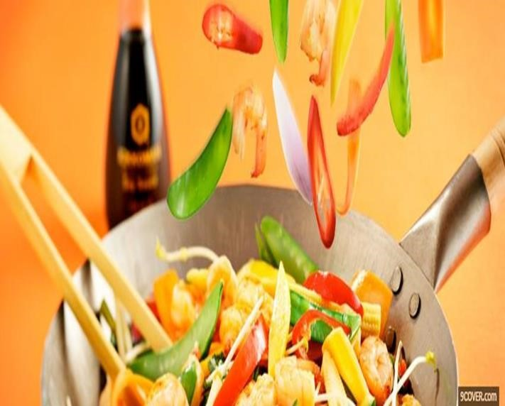

SMART

MEALS

**Giving your Hunger a new Option**

Yummy food which will please your time,

money and tummy.

So, just

eat and

forget everything else.

We care for your

precious time.

INTELLECT SOFT

Software Engineering

# SMART MEALS

**Introduction**

* Details of the Project:

It is globally known; that in today’s market, it is extremely difficult to start a new business and face the competition through the well-established and settled owners. In today’s fast paced time, when everyone is squeezed for time, most people are annoyed when it comes to ordering food. Today’s consumers are attracted not only because it is very easy to order online but also because they have visibility on items offered, the price and extremely simplified navigation for the order.

Online ordering system that we are proposing here; made the ordering process easier for those who want **home-cooked food**. We basically provide a platform for domestic food providers, so they can link with the customers through us and earn handsome amount. We will provide delivery to the customer within specific area and specific time limit. Our service will not be **24/7** as it becomes difficult for food providers because they have to make fresh food on every order that takes some time.

As it is difficult to start a new business in this age of competition so we will commence from ***70%*** share of domestic food providers and our share will be ***30%***. After becoming well-known food providers, we will increase our share to ***40% (after one year).***

* Purpose:

Our primary purpose is to provide a platform to those women who cannot go outside but wants to earn money. It will be ease for patients and hostel students to order home-cooked food because one become fed up of eating fast food daily.

* Intended Audience:

The project is basically intended for customers and domestic food

providers.

➢ Product Scope:

Domestic food providers will provide food ordered by customers

within a specific time and we will deliver it. Delivery will be only within Lahore and in specific areas. It will take maximum one hour for delivery. We will provide information about possible available items within that area in which customer is present so he can easily check and place order. Delivery would be as fast as possible because it is a basic characteristic of a successful team to do work on time.

**USE CASE DIAGRAM**

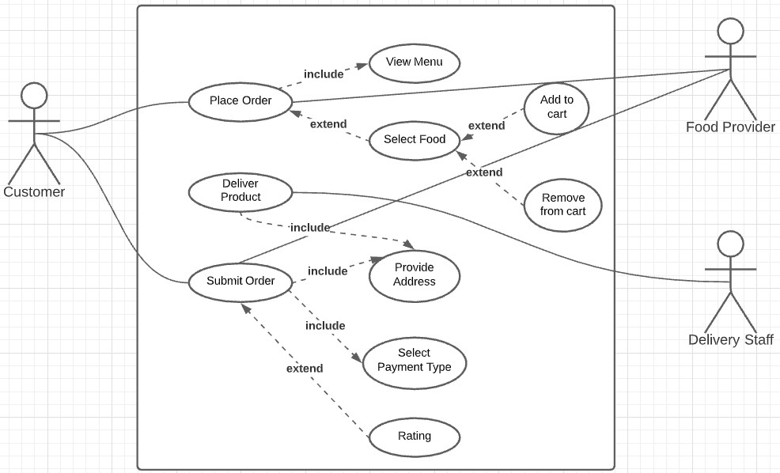

**Use Case Descriptions**

|  |  |
| --- | --- |
| **Title:** | **Smart Meals** |
| **ID:** | Menu |
| **Description:** | User accesses the system and **view the Menu**, then he chooses food and submit the order |
| **Primary Actor:** | Customer |
| **Secondary Actor:** | * Food Provider * Delivery Staff |
| **Preconditions:** | Customer access the website |
| **Postconditions:** | Customer placed an order |
| **Main Success Scenario:** | 1. Customer selects “Menu” 2. System displays list of food available to choose 3. Customer selects food and he can choose one or more options if he wants to order more 4. Customer selects a “Delivery Location” 5. Customer clicks “Submit Order” 6. System registers the customer’s order for the selected items and displays a confirmation message |
| **Extensions:** | 3a) No Food is available  __3a1) System display error message saying: This  food is not available at this hour  __3a2) Customer either backs out of this use case and tries again later  4a) No delivery is available  __4a1) Customer is out of specific area  5a) Order can’t be registered  __5a1) System shows error message and provide a valid reason |
| **Frequency of Use:** | Every time when customer visits |
| **Status:** | Parallel Reviews |
| **Owner:** | **Intellect Soft** |
| **Priority:** | High |

**Activity Diagrams**

**Menu**

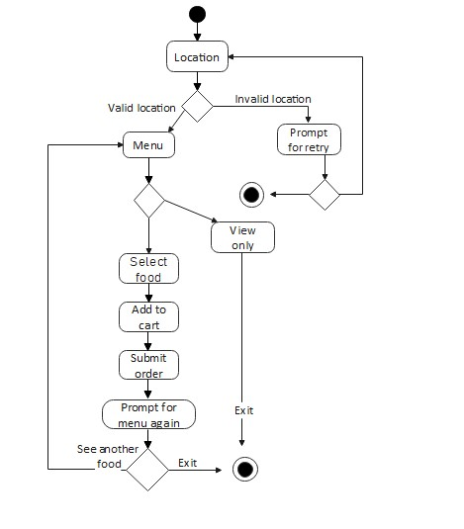

**Submit Order**

